**Svar på oppgaver:**

**Problem 1:**

Given the definition for water/oil:

$$X_{w}=\frac{V_{w}}{V}$$

And the volume deffinition:

$$V=V_{w}+V_{o}$$

We can assume:

$$V=V\left(X_{w}+X_{o}\right)$$

$$X_{o}=1-X_{w}$$

Turning the volume to mass and inserting everything

$$ρV=ρ_{w}V_{W}+ρ_{o}V_{o}$$

$$ρ=ρ_{w}X_{w}+\left(1-X_{w}\right)ρ_{o}$$

**Problem 2:**

1. We have EoS for liquid mixture expressed as $dρ$, and isothermal compressibility expressed as $β_{T}$

$$dρ=\frac{∂ρ}{∂P}dP+\frac{∂ρ}{∂T}dT$$

$β_{T}=\frac{1}{ρ}\frac{∂ρ}{∂P}$

With temperature neglected

$\frac{∂ρ}{∂T}dT=0$

we get

$ρ=\frac{∂ρ}{∂P}dP$

Rearranged isothermal compressibility

$β_{T}ρ=$ $\frac{∂ρ}{∂P}$

Plug in rearranged isothermal compressibility for $\frac{∂ρ}{∂P}$ in EoS for liquid mixture

$dρ= β_{T}ρ dP$

$$dρ=ρβ_{T}dp→ \frac{dρ}{ρ}=β_{T}dp$$

$\int_{ρ_{0}}^{ρ}{\frac{dρ}{ρ}}=\int_{p_{0}}^{p}{β_{T}dp }$

$\ln{\frac{ρ}{ρ_{0}}= β_{T}\left(p-p_{0}\right)}$

$$\frac{ρ}{ρ_{0}}=e^{β_{T}\left(p-p_{0}\right)}$$





**Problem 3:**

We assume $dρ=0$ then $ρ$ constant, therefore:

$$ρ = ρ_{0}$$

$ρ=ρ_{0}e^{β\left(p-p_{o}\right)}$

$$lnρ/p0$$

$$=\left(β\left(p-p_{0}\right)\right)\log\left(ρ_{0}\right)$$

$$β\left(p-p_{0}\right)=\log\left(ρ\right)-\log\left(ρ_{0}\right)$$

Since $ρ=ρ_{0}$:

$$\log\left(ρ\right)-\log\left(ρ_{0}\right)=0$$

$$β\left(p-p_{0}\right)=0$$

$$p-p_{0}=0$$

$$p=p_{0}$$

Since the density is constant there is also possible to say that the pressure is constant.

**Problem 4:**

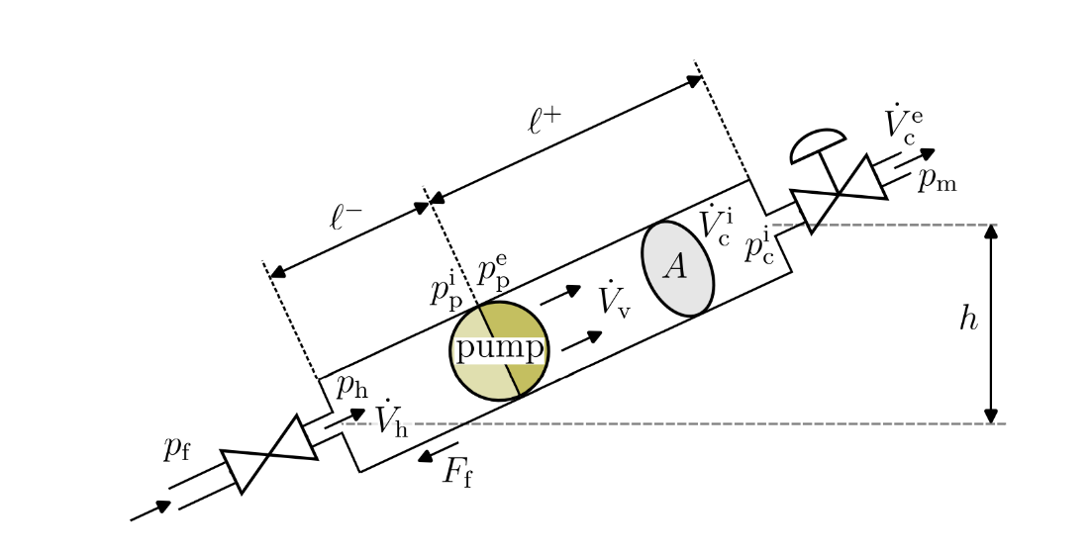

1. If we say that: $\dot{V_{h}}=C_{\dot{V}}^{π}\frac{p_{f}-p_{h}}{p_{π}^{δ}}$ and $\dot{V_{h}}ρ= \dot{m_{h}}$ then:

$$\frac{dm}{dt}=\dot{m_{f}}-\dot{m_{h}}$$

$$\dot{V_{h}}=\frac{\dot{m_{h}}}{ρ_{h}}$$

$$\dot{m_{h}}=ρC_{\dot{V}}^{π}\frac{p_{f}-p_{h}}{p_{π}^{δ}}$$

$$\frac{dm}{dt}=\dot{m_{f}}-ρC_{\dot{V}}^{π}\frac{p_{f}-p_{h}}{p_{π}^{δ}}$$

$$\frac{dm}{dt}=\dot{m_{f}}-\dot{m_{h}}$$

**Problem 5**

1. The total force F can be expressed as:
$$F=F_{p}+F_{b}-F_{f}-F_{g}$$

$$F=p_{h}A-p_{c}^{i}A-Δp_{p}A-Δp_{f}A-Δp_{g}A$$

$$F=A\left(p_{h}-p_{c}^{i}-Δp_{p}-Δp_{f}-Δp_{g}\right)$$

2. The pressure changes $Δp_{p}$ and $Δp_{f}$ are pending on the following models:

$$Δp_{p}=ρgh_{p}$$

Where $h_{p}$ is an function of $h_{p}\left(\dot{V},f_{p}\right)$

$$Δp_{f}=f_{D}\frac{ρ}{2}\frac{V^{2}}{D}l$$

**Problem 6:**

**1:**

Given:

$$\frac{dM}{dt}=M_{i}-M_{e}+F$$

Where defined:

$$M=mv$$

Inserting and moving constants out

$$m\frac{dv}{dt}=M_{i}-M_{e}+F$$

And assuming m_i = m_e

$$m\frac{dv}{dt}=F$$

**2:**

given:

$$\frac{dM}{dt}=m_{i}-m_{e}+F$$

$$F_{p}=p_{h}A-p_{c}^{i}A$$

$$F_{b}=∆p_{p}A$$

$$F_{f}=∆p_{f}A$$

$$F_{g}=∆p_{g}A$$

$$∆p_{g}=ρ_{v}gh$$

Where:

$$F=\sum{F}=F_{p}+F_{b}-F_{f}-F_{g}$$

$$F=p_{h}A-p_{c}^{i}A+∆p_{p}A-∆p_{f}A-∆p_{g}A$$

$$F=A_{V}\left(p_{h}-p_{c}^{i}+∆p_{p}-∆p_{f}-∆p_{g}\right)$$

And:

$$\frac{dM}{dt}=\frac{dρAlv}{dt}=ρl\frac{dAv}{dt}=ρl\frac{dV_{v}}{dt}$$

Giving the final transformation:

$$m\frac{dv}{dt}=F→ \frac{dV_{v}}{dt}=\frac{A_{v}}{ρ_{v}l}\left(p_{h}-p_{c}^{i}+∆p_{p}-∆p_{f}-∆p_{g}\right)$$